Nepal College of Information Technology
Unit Test 2009

Program: BE Time: 2 hrs
Semester: Spring FM: 60
Subject: Engineering Math-IV PM: 30

1. a) Define analytic function and harmonic function. Prove that u = y³-3x²y is a harmonic function. Determine its harmonic conjugate v of function f(z). 8
b) State and prove Cauchy’s Integral theorem.
OR
If a complex valued function f(z) = u(x,y) + iv(x,y) is defined and continuous in some neighborhood of a point z = x +iy and differentiable at z itself, then at that point, prove that u and v satisfy Cauchy Riemann equation u_{x} = v_{y} and u_{y} = - v_{x}

2. a) Check analyticity for f(z) = Coshz. 5
b) 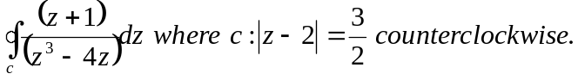 5
c) Define Z-transform and prove Z-transform of a^{n} is z /(z – a). 5
3. a) Find Z- transform of Z (e^{-iat}) and hence deduce the values of Z(sinat) and Z(Cosat). 7
b) Define Convolution of two functions. If F(z) and G(z) are Z-transform of f(t) and g(t), then show that Z[f(t)*g(t)] = F(z) G(z). 8
Or
Show that 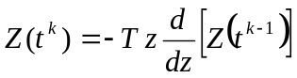
4. a) Solve the differential equation: y _{n+2}– 4y_{n+1} + 4y_{n} = 0 where y₀ = 1, y₁ = 0. 8
b) Find the Inverse Z-transform of 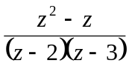 7
Nepal College of Information Technology
Unit Test 2009

Program: BE Time: 2 hrs
Semester: Spring FM: 60
Subject: Engineering Math-IV PM: 30

1. a) Define analytic function and harmonic function. Prove that u = y³-3x²y is a harmonic function. Determine its harmonic conjugate v of function f(z). 8
b) State and prove Cauchy’s Integral theorem.
OR
If a complex valued function f(z) = u(x,y) + iv(x,y) is defined and continuous in some neighborhood of a point z = x +iy and differentiable at z itself, then at that point, prove that u and v satisfy Cauchy Riemann equation u_{x} = v_{y} and u_{y} = - v_{x}

2. a) Check analyticity for f(z) = Coshz. 5
b) 5
c) Define Z-transform and prove Z-transform of a^{n} is z /(z – a). 5
3. a) Find Z- transform of Z (e^{-iat}) and hence deduce the values of Z(sinat) and Z(Cosat). 7
b) Define Convolution of two functions. If F(z) and G(z) are Z-transform of f(t) and g(t), then show that Z[f(t)*g(t)] = F(z) G(z). 8
Or
Show that
4. a) Solve the differential equation: y _{n+2}– 4y_{n+1} + 4y_{n} = 0 where y₀ = 1, y₁ = 0. 8
b) Find the Inverse Z-transform of 7

